On a 2D plane, there are n points with integer coordinates points[i] = [xi, yi]. Return *the****minimum time****in seconds to visit all the points in the order given by*points.

You can move according to these rules:

* In 1 second, you can either:
  + move vertically by one unit,
  + move horizontally by one unit, or
  + move diagonally sqrt(2) units (in other words, move one unit vertically then one unit horizontally in 1 second).
* You have to visit the points in the same order as they appear in the array.
* You are allowed to pass through points that appear later in the order, but these do not count as visits.

**Example 1:**

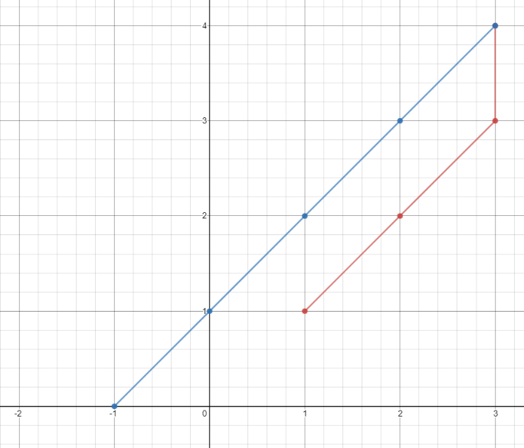

**Input:** points = [[1,1],[3,4],[-1,0]]

**Output:** 7

**Explanation:** One optimal path is **[1,1]** -> [2,2] -> [3,3] -> **[3,4]** -> [2,3] -> [1,2] -> [0,1] -> **[-1,0]**

Time from [1,1] to [3,4] = 3 seconds

Time from [3,4] to [-1,0] = 4 seconds

Total time = 7 seconds

**Example 2:**

**Input:** points = [[3,2],[-2,2]]

**Output:** 5

**Constraints:**

* points.length == n
* 1 <= n <= 100
* points[i].length == 2
* -1000 <= points[i][0], points[i][1] <= 1000